# Teem activity 05

Write a question to answer. The questions should include questions that will require, (conditions, Table Joins, Aggregates)

1. The question being asked.

What are the total sales for each category?

1. Team member name that lead the discussion for this question.
   * Francisco Javier Aguirre
2. SQL query used to answer the question.

SELECT category.category_name,

SUM(product.list_price * cust_order_item.quantity) AS total_sales

FROM product

JOIN category ON product.category_id = category.category_id

JOIN cust_order_item ON product.product_id = cust_order_item.product_id

GROUP BY category.category_name;

1. Query results, either as a screen shot or table.

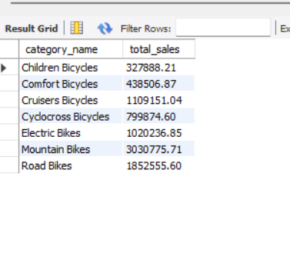

1. The question being asked.

What are the product categories with the highest sales?

1. Team member name that lead the discussion for this question.
   * Stanley Bruss Mauricio
2. SQL query used to answer the question.

FROM product

JOIN category ON product.category_id = category.category_id

JOIN cust_order_item ON product.product_id = cust_order_item.product_id

GROUP BY category.category_name

ORDER BY total_sales DESC;

1. Query results, either as a screen shot or table.

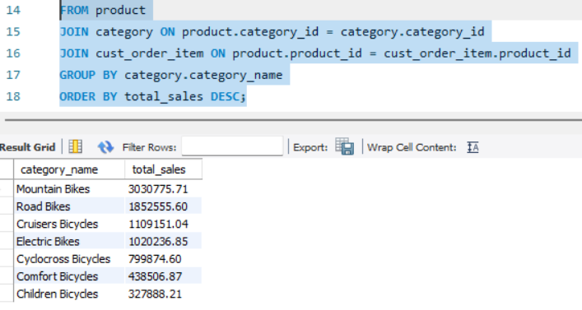

1. The question being asked.

what is the average price of the products in each category?

1. Team member name that lead the discussion for this question.
   * Franco Gabriel Zarate
2. SQL query used to answer the question.

SELECT category.category_name,

FORMAT(AVG(product.list_price), 2) AS average_price

FROM product

JOIN category ON product.category_id = category.category_id

GROUP BY category.category_name with rollup;

1. Query results, either as a screen shot or table.

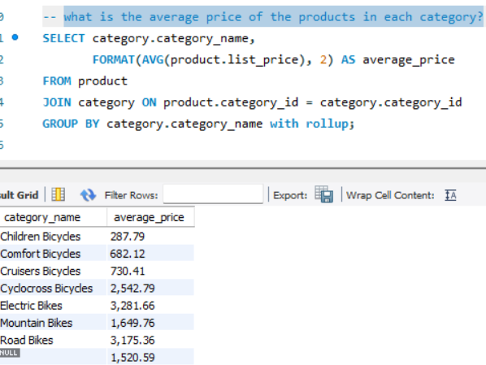

1. The question being asked.
2. The question being asked.

How many artworks are associated with a specific keyword?

1. Team member name that lead the discussion for this question.

Agustin Ezequiel Heredia y Darwin Gualberto Torrejón.

1. SQL query used to answer the question.

SELECT keyword.keyword, COUNT(artwork_keyword.artwork_id) AS num_artworks

FROM keyword

JOIN artwork_keyword ON keyword.keyword_id = artwork_keyword.keyword_id

GROUP BY keyword.keyword;

1. Query results, either as a screen shot or table.

